Data definition language
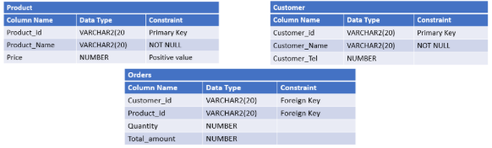
1/ Customer Table
CREATE TABLE Customer (
Customer_id VARCHAR(20) PRIMARY KEY,
Customer_Name VARCHAR(20) NOT NULL,
Customer_Tel NUMBER
);
2/ Product Table
CREATE TABLE Product (
Product_id VARCHAR(20) PRIMARY KEY,
Product_Name VARCHAR(20) NOT NULL,
Price NUMBER CHECK (Price > 0)
);
3/ Orders Table
CREATE TABLE Orders (
Customer_id VARCHAR(20) FOREIGN KEY,
Product_id VARCHAR(20) FOREIGN KEY,
Quantity NUMBER,
Total_amount NUMBER
);
4/ Add a column Category (VARCHAR2(20)) to the PRODUCT table
ALTER TABLE Product ADD Category VARCHAR2(20);
5/ Add a column OrderDate (DATE) to the ORDERS table which have SYSDATE as a default value
ALTER TABLE Orders ADD OrderDate DATE DEFAULT SYSDATE ();

